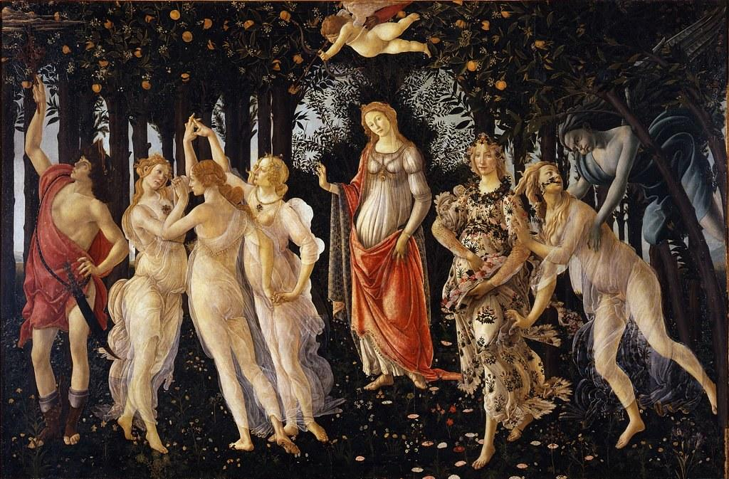

Sonnets For Spring by Sandro Botticelli (In the Accademia of Florence)

By Dante Gabriel Rossetti

# 

## Sonnet For Spring by Sandro Botticelli (In the Accademia of Florence)

By Dante Gabriel Rossetti (1828 - 1882)

What masque of what old wind-withered New-Year

Honours this Lady? Flora, wanton-eyed

* For birth, and with all flowrets prankt and pied:

Aurora, Zephyrus, with mutual cheer

Of clasp and kiss: the Graces circling near,

* 'Neath bower-linked arch of white arms glorified:
* And with those feathered feet which hovering

glide

O'er Spring's brief bloom, Hermes the harbinger.

Birth-bare, not death-bare yet, the young stems

* stand,

This Lady's temple-columns: o'er her head

* Love wings his shaft. What mystery here is read

Of homage or of hope? But how command

Dead Springs to answer? And how question here

These mummers of that wind-withered New-

* Year?

## Further Information about the Artwork:

**Artist/Maker:** [Sandro Botticelli](https://artuk.org/discover/artists/botticelli-sandro-144414451510) (Italian, c. 1445 - 1510)

**Date:** circa 1480

**Medium:** Tempera grassa on wood

**Dimensions:** 207 x 319 cm

**Resides In:** [The Uffizi, Italy](https://www.uffizi.it/en/artworks/botticelli-spring)

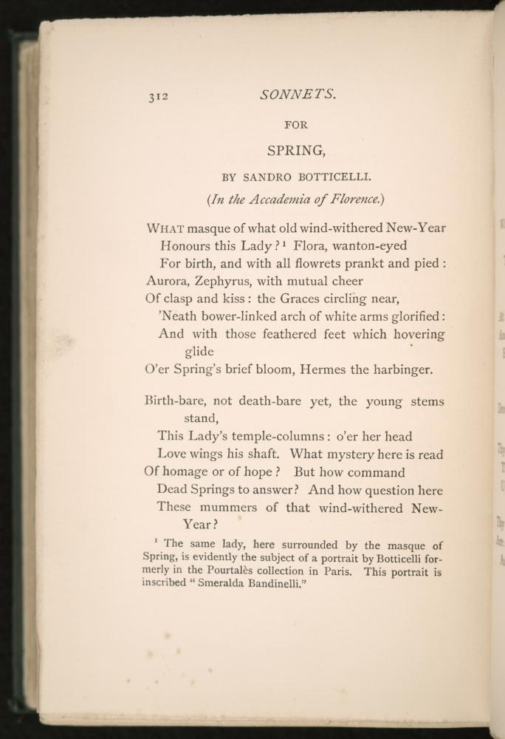

Creative Commons License

This work is licensed under a [Creative Commons Attribution 4.0 International License](http://creativecommons.org/licenses/by/4.0/).